Project Case | 
COMP7126
Artificial Intelligence in Games
Computer Science | O202-COMP7126-RZ04-00
Valid on Odd Semester Year 2019/2020 | Revision 00

- Seluruh kelompok tidak diperkenankan untuk:
The whole group is not allowed to:
    - Melihat sebagian atau seluruh proyek kelompok lain,
Seeing a part or the whole project from other groups
    - Menyadur sebagian maupun seluruh proyek dari buku,
Adapted a part or the whole project from the book
    - Mendownload sebagian maupun seluruh proyek dari internet,
Downloading a part or the whole project from the internet,
    - Mengerjakan soal yang tidak sesuai dengan tema yang ada di soal proyek,
Working with another theme which is not in accordance with the existing theme in the matter of the project,
    - Melakukan tindakan kecurangan lainnya,
Committing other dishonest actions,
    - Secara sengaja maupun tidak sengaja melakukan segala tindakan kelalaian yang menyebabkan hasil karyanya berhasil dicontek oleh orang lain / kelompok lain.
Accidentally or intentionally conduct any failure action that cause the results of the project was copied by someone else / other groups.

- Jika kelompok terbukti melakukan tindakan seperti yang dijelaskan butir 1 di atas, maka nilai kelompok yang melakukan kecurangan (menyontek maupun dicontek) akan di – NOL – kan.
If the group is proved to the actions described in point 1 above, the score of the group which committed dishonest acts (cheating or being cheated) will be “Zero”

- Perhatikan jadwal pengumpulan proyek, segala jenis pengumpulan proyek di luar jadwal tidak dilayani.
Pay attention to the submission schedule for the project, all kinds of submission outside the project schedule will not be accepted

- Jangan lupa untuk melihat kriteria penilaian proyek yang ditempel di papan pengumuman, atau tanya asisten anda.
Don’t forget to look at the project assessment criteria that posted on the announcement board, or ask your teaching assistant.

- Persentase penilaiaan untuk matakuliah ini adalah sebagai berikut:
Marking percentage for this subject is described as follows:

Tugas Mandiri  Assignment | Proyek  Project | UAP  Final Exam
40% | 60% | -

- Software yang digunakan pada matakuliah ini adalah sebagai berikut:
Software will be used in this subject are described as follows:

Software
Software
Java 8
Eclipse Neon 3

Ekstensi file yang harus disertakan dalam pengumpulan tugas mandiri dan proyek untuk matakuliah ini adalah sebagai berikut:
File extensions should be included in assignment and project collection for this subject are described as follows:

Tugas Mandiri  Assignment | Proyek  Project
JAVA, CLASS | JAVA, CLASS

Soal
Case

RuZ Second

RuZ Second is a video game franchise, where player must compete with other player to be the first to get the treasure. The game is still on the pitch, but unfortunately the company doesn’t know whether the game has its potential or not. The company need to make the game prototype, so they hire you as a programmer to make the game prototype in Java Programming Language.

The following are the specifications that you need to follow in building your prototype:
- Game Menu
  - Show the game title “RuZ Second” with the font “ROG Fonts”.
  - Show the game objective with text “Objective: Reach the goal first”.
  - Show 3 buttons, with each button determines the game’s difficulty.
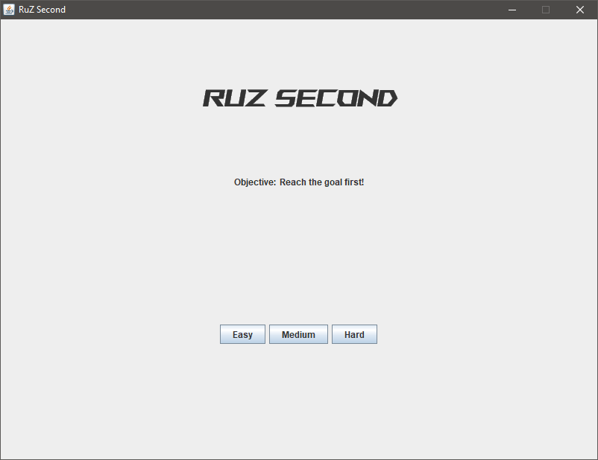
Figure 1. Game Menu

- Game World
- There are 3 levels in the game:
  - Easy
    - The maze consists of 15 x 15 tiles (including borders).
    - The tile size is 40 unit.
    - The enemy move cooldown is 0.6 second.
    - Goal score is 100, with reduction 3 per second.
    - Killing score is 20.
  - Medium
    - The maze consists of 27x27 tiles (including borders).
    - The tile size is 22 unit.
    - The enemy move cooldown is 0.4 second.
    - Goal score is 250, with reduction 4 per second.
    - Killing score is 40.
  - Hard
    - The maze consists of 35x35 tiles (including borders).
    - The tile size is 17 unit.
    - The enemy move cooldown is 0.2 second.
    - Goal score is 800, with reduction 5 per second.
    - Killing score is 50.
- The details about ‘killing’ can be seen in Section 3 (Player).
- The maze is procedurally generated by using Depth First Search Algorithm.
  - After the maze is generated, special tiles will be placed on the maze. These special tiles are player, enemies and the goal.
  - It is recommended to generate the maze from the center to prevent a long path generation due to the algorithm.
  - The details on the tiles can be seen in Section 2 (Tiles).
- Tiles
There are five different tiles that can be placed in the game world. Two of the tiles compose the maze, while the other three of them are special tiles.

These two tiles are the tiles that compose the maze.
Tile | Color(RGB) | Description | Count
Floor | 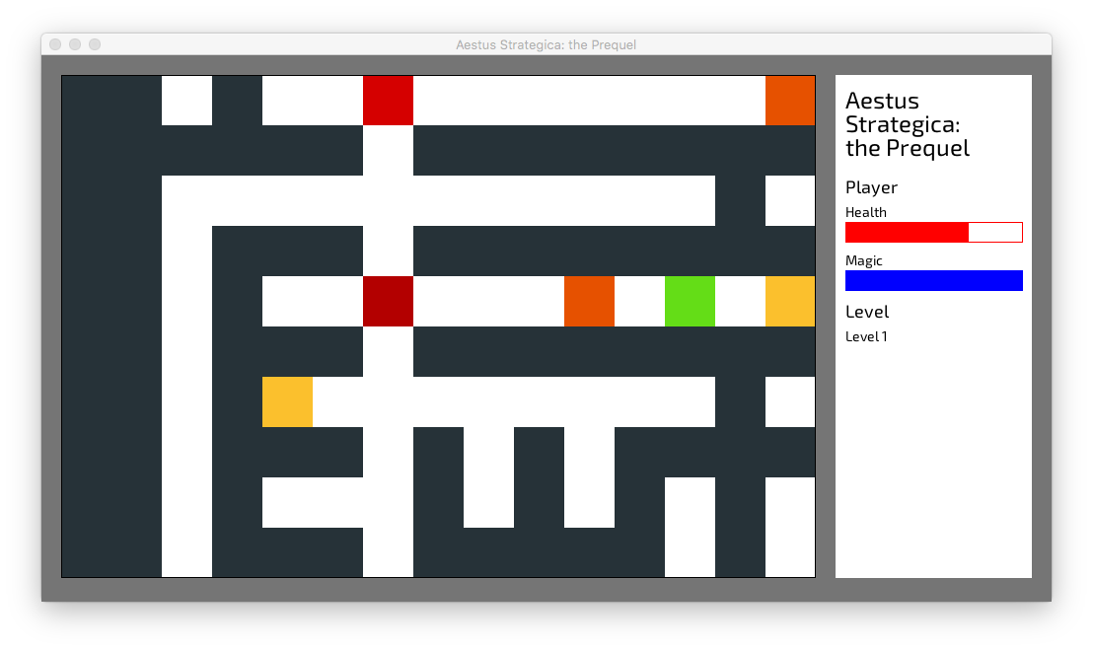  (255,255,255) | - Player and enemy may step and pass through this tile | Depends on the maze generation
Wall | (0,0,0) | - Player and enemy cannot step or go through this tile | Depends on the maze generation

These three tiles are special tiles.
Tile | Color(RGB) | Description | Count
Player | (0,0,255) | - Player is spawned in one of the maze corners | One
Enemy | (255,0,0) | - Enemy is spawned in the rest of the maze corners | Three
Goal | (0,255,0) | - If player reached the goal, player wins the game  - If an enemy reached the goal, player loses the game  - Goal is spawned in the middle of the maze, with walls removed in 4 direction | One

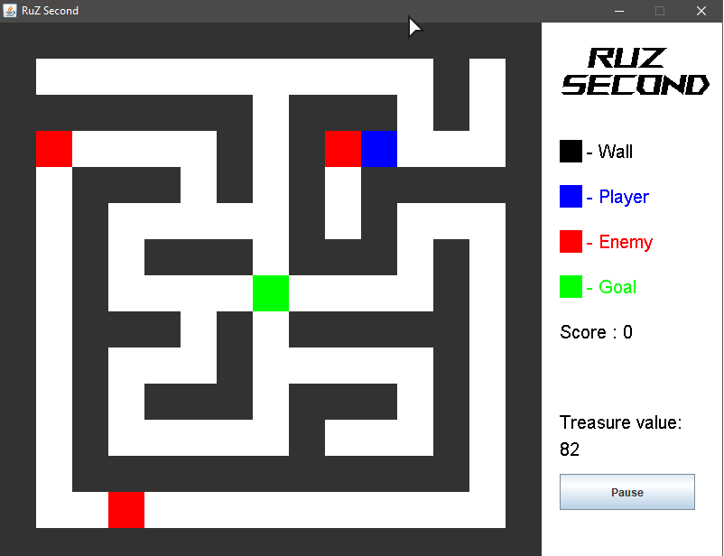
Figure 2. Special tiles are generated after maze generation
- Player
The player is the controllable character in the game. The player may be moved by user input.
- Movement
  - Player can be moved by using the directional keys on the keyboard.
  - Player may not go through the wall tile.
Key | Player Movement
Arrow Up (↑) | Up
Arrow Down (↓) | Down
Arrow Left (←) | Left
Arrow Right (→) | Right
  - The button mapping are as follows:

- Attack
  - Player and enemy can attack each other by moving towards target, “killing” the target unit.
  - Player will get score from killing enemy depending on the difficulty.
  - When player is killed, player will lose the game.

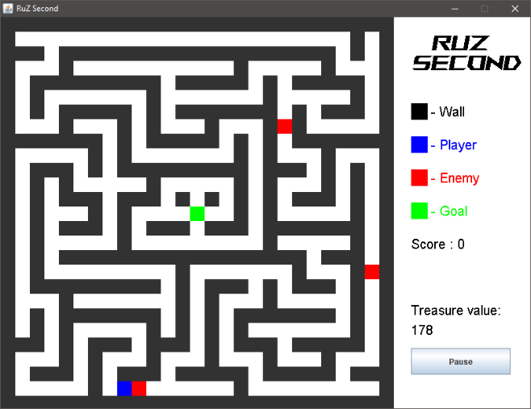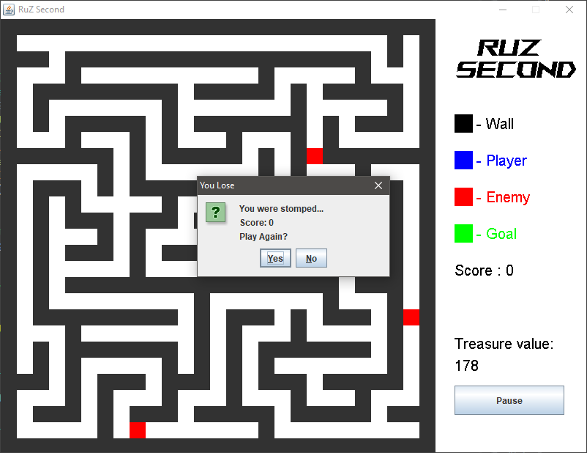
Figure 3. Player and Enemy beside each other Figure 4. Player being killed by enemy

- Enemy
Enemy is an uncontrolled player that also must reach the goal.
- Movement
  - Enemy movement follows the maze’s traveling rule “Always turn left”.
  - Enemy will always move with the following as a priority:
    - Turn left
    - Move forward
    - Turn right
    - Turn backward
  - Enemy may not go through wall tiles.
  - Enemy will move with delay, which depends on the difficulty.
- Attack
- Similar with player, enemy can also kill another unit.
- If enemy is killed, they will respawn to one of 4 corners randomly.

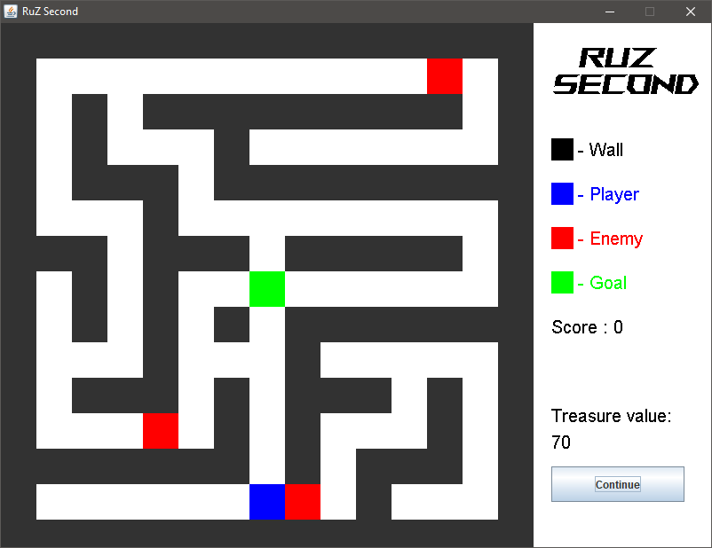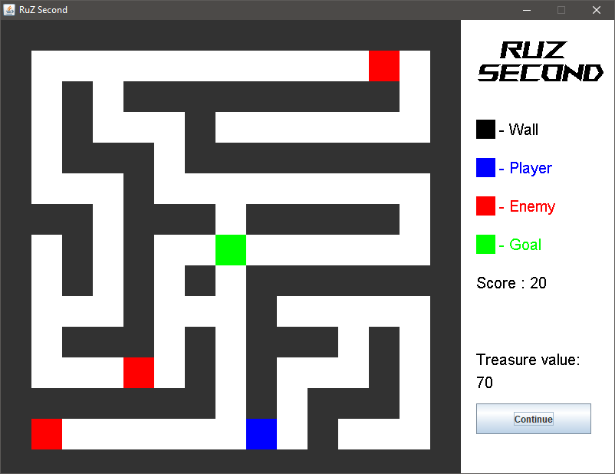
Figure 5. Player and Enemy beside each other Figure 6. Enemy Respawned after being killed

- Info Panel
The info panel shows the details regarding the game. The panel shows details about the Player and the game information.
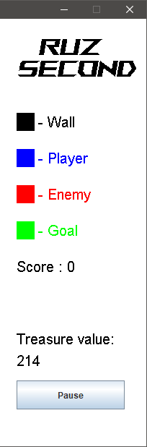 | Game Title  The upper section of the info panel contains the game name, RuZ Second.
Level Information
The level information consists of:
- The color of tiles and the unit that it represents.
- Player’s score,
- Treasure’s current value.

Note: The font style is “Roboto”
Controls
Show the button “Pause” on the bottom.

- Pause
Player can pause the game by pressing the pause button.
When player paused the game:
- Change the pause button text to “Continue”.
- Stop player & enemy movement. The treasure’s value will not be reduced when paused.
- Player can continue when they press the button again.

- Game Over
Game is over when:
- Player reached the goal.
  - If player reached the goal, show the panel with text “You finally found the treasure!”.
  - Show the title “You Win!”.
- Enemy reached the goal.
  - If an enemy reached the goal, show the panel with text “The enemies got it first...”.
  - Show the title “You Lose”.
- Player is killed.
  - If an enemy reached the goal, show the panel with text “You were killed...”.
  - Show the title “You Lose”.

Also show the player score, and “Play Again?” text.
The player score is calculated with the following formula:
Score = Number of kills * Killing score + Treasure’s value

The game will ask the player whether they want to play again or not.
Use JOptionPane to show the game-over window.

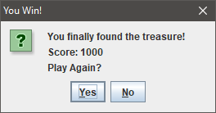
Figure 7. Restart dialog box

If the player clicks “Yes”, the game will be redirected to main menu. Otherwise, the application will exit.

Here are the rules that you must follow to create your project:
- Use appropriate software for this subject based on Sistem Praktikum that can be downloaded from Binusmaya.
- Collect appropriate files for this subject based on Sistem Praktikum that can be downloaded from Binusmaya.
- Include the other files that can support your project, such as:
  - All files in your project
  - Other files (image, audio, video, etc.) used in your project
  - *.DOC file (documentation of your project) that contains all pages in your project, reference links of additional files (image, audio, video, etc.) used in your project, the description about how to use your application, etc.

